
SAVANNAH, GEORGIA
July 29 – August 6, 2011

FACILITIES and LODGING
Be warned…there is a TRIVIA test!

Parade headquarters and host to many of our major indoor events, is the Savannah International Trade & Convention Center (SITCC). Here old world charm meets new world meeting space on the southern shore of the Savannah River. Hospitality, Goodie Store, Art Show and our major banquets along with many of your other favorites will reside in the SITCC. Find Bryan Square at the entrance, where you can stop for refreshment at our Welcome Tent when you first arrive.

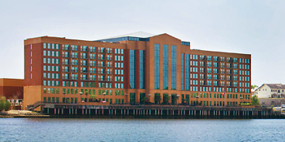

North of the river we find two of our host hotels, along with a bustling street full of shops and eateries (including some of the best pralines to be had!)

The Marriott Savannah Riverfront is a thrifty option. This location boasts quick access to City Market and the historic district, including the opportunity for a horse-drawn carriage ride! Spa, indoor & outdoor pools and the water taxi are readily available.

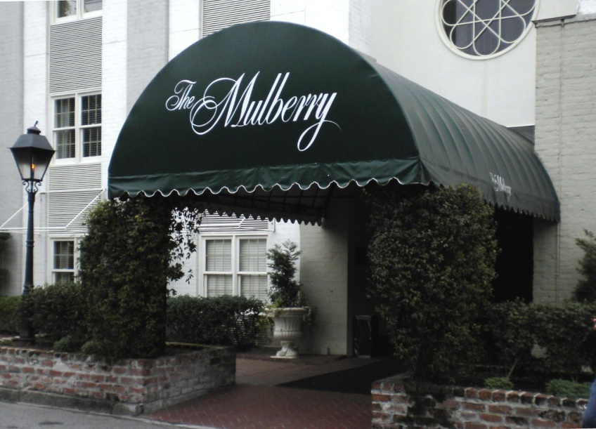

Another thrifty option is the quaint Mulberry Inn in the heart of downtown. This charming hotel was built in 1860 and has a colorful history. The Inn features afternoon tea and an outdoor pool. It is also pet friendly!

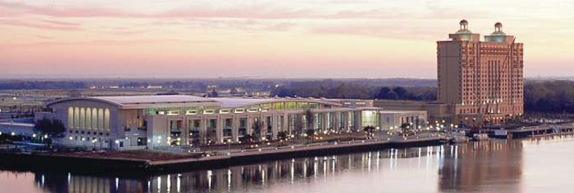

On the island is the Westin Savannah Harbor Golf and Spa, which is a AAA four-diamond resort. Expect to pay a premium for those four diamonds! Just this year they completed renovation of their pool, part of a beautiful riverfront patio oasis. Part of the Westin complex are the Harbor Club Spa and fitness center and Troon-managed Harbor Golf Course. And now time for that trivia quiz. What race track also shares the island? Car buffs may know that trailing around and through the golf course, is a 2.1 mile roadway worthy of a Helio Castroneves win at the 1997 Grand Prix.

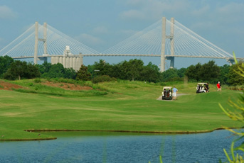
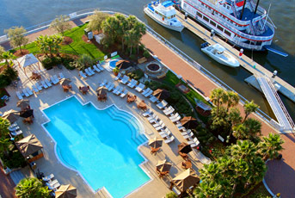

Concours prep and car wash facilities will be available at the Convention Center and car wash facilities will be available at the Marriott.

Savannah is the largest single terminal container port on the US Atlantic coast, and we guarantee distraction caused by these large ships as they pass. Outside of the intermittent exceptions as these vessels float through, the river taxi service runs a frequent triangular route connecting north & south river destinations. Those staying on either side will find stops on the back patio of both the Westin and the Marriott. From the Mulberry, the stop is a block away. It takes 6 – 10 minutes to cross the river, typically faster than even our Porsche’s can get across the Talmadge Bridge.

PARKING
All 3 hotels and the Convention Center have paved parking, see associated fees below.
AREA ACTIVITIES
Savannah is known for its 22 distinct city “squares”, each are part of the original city network. Nearby is Forsyth Park where we have been fortunate to secure the grounds for our Concours.

Also unique to this city is legend. If one can associate “somewhere, USA” with Halloween, it would be Savannah! Yes, there truly is a ghost and gravestone tour company! Georgia’s first city is enchanting- both romantic and haunted. Perhaps it began with lush botanicals. One of the first features you’ll notice as you drive in is the hanging Spanish moss. The beaches of Tybee Island are only 20 minutes away.

Lest we forget your palate, Paula Deen and her sons call this city home. And of course – if you can find time, there is more golf and beaches to be found at Hilton Head – about 45 minutes away.
Please find area information at: http://parade2011.pca.org/localattractions.html

REGISTRATION
Opens at www.pca.org on March 8. You will need to register for Parade FIRST, then follow by booking your room using an authorization code that will be provided. At that point you are eligible for the group rates as shown below. Rates available before & after official Parade dates are noted below if you wish to extend your visit. Our room blocks release July 1 along with this special rate.

Marriott Savannah Riverfront –
Rate: $125 double occupancy, plus $20 for each additional person. Taxes will also be applied, current rate is $13% per room, per night, plus $1.00 occupancy tax per room, per night (subject to change). Our PCA rate is available up to 2 days before and after Parade dates. If available upon request, upgrades to Riverfront/Riverview rooms are charged an additional $20/night.
Parking Fee: $10 daily self-park rate (or park at the convention center)
Internet: provided complimentary, as is access to the fitness center and recreation facilities.
Options: a couple of Junior suites are among our block, available first-come, first-served at $155/night. Other charges apply as above.
Pet Friendly: Sorry but No
Check-in: 4 pm, check-out by 11:00 am on the day of departure
URL: http://www.marriott.com/hotels/travel/savrf-savannah-marriott-riverfront/
Phone: (912) 233-7722 or (800)285-0398

Mulberry Inn–
Rate: $129/night. Taxes will also be applied; current rate is $13% per room, per night, plus $1.75 occupancy tax per room, per night (subject to change). Our PCA rate is available up to 2 days before and after Parade dates.
Parking Fee: Complimentary for one car; convenient garage parking.
Internet: provided complimentary, along with use of the fitness center and recreation facilities
Options: Standard rooms feature king or dual queen, limited suites are available at $169/night.
Pet Friendly: Yes, with a $75 one-time fee.
Check-in: 4 pm, check-out by 11:00 am on the day of departure
URL: http://www.savannahlodging.com/
Phone: (912) 238-1200

Westin Savannah Harbor Golf Resort & Spa –

Rate: $139 double occupancy, plus $20 for one additional guest, & $10 for a 4th. There is no charge for children under 18. Taxes will also be applied; current rate is $13% per room, per night, plus $1.75 occupancy tax per room, per night (subject to change). Our PCA rate is available up to 3 days before and after Parade dates.
Fee: A daily resort fee of $19/night is charged to cover parking, in-room internet, on site shuttle service and use of the fitness center.
Pet Friendly: Yes, with a $100 one-time fee
Check-in: 4 pm, check-out by noon on the day of departure
URL: http://www.westinsavannah.com/
Phone: (912) 201-2000 or (800) 937-8461

You make the drive, we’ll provide the oasis!

